**THE BUSINESS ENVIRONMENT**

The environment of a business refers to those factors or constraints that affect the performance of a business. These constraints originate from within and outsides the organization. Those that originate within the organization constitutes the internal environments of business and those from outside constitutes the external environment of a business.

**INTERNAL ENVIRONMENT OF BUSINESS**

These constraints that originate from within the organization and can easily be controlled by management include:

1. **The organizational charter**

The organization’s charter details the constitution, purpose and mission of the organization. This highlights scope of operation of an organization i.e. the type of products and services to be produced and the areas (markets) to be served.

1. **Policies, procedures and rules (standing plans)**

Policies provide the framework within which decision making and action takes place. Procedures indicate the sequence of events or steps to be taken in handling a specific task.

Rules prescribe what one can and cannot do. Management actions and decisions are greatly influenced by (based on) these internal plans.

1. **Capital (finance)**

Finance is essential to the growth, expansion and survival of any organizations. It is needed in accessing and maintaining the other factors of production. There are competing uses for the limited finance available e.g. marketers need finance for the promotional campaigns, human resource managers need finance to attract the most qualified labor etc.

1. **Human resources**

If the human resource available has education, skills training and experience there will be less need for supervision and control and their contribution to performance will be positive and vice versa.

1. **Managerial skills (Talents available)**

The more skilled and experienced the management staff, the better the direction they will give to the employees and the better will be the results.

**EXTERNAL ENVIRONMENT**

This constitutes of factors that originate from outside the organization that are not easily controllable by management. There are five main factors in the external environment that impact on the performance of an organization.

1. Economic Environment
2. The market (competitive) environment
3. The technological environments
4. Political – legal environments
5. Social – culture environment
6. **ECONOMIC ENVIRONMENT**

The economic environment can be divided into two broad categories

1. The general economic conditions
2. The factor market

**a) General economic condition.**

They include

i. The economic system in place. This can be socialists, capitalistic or mixed economy. Capitalistic economies are more favorable to private enterprises than the other two.

ii. National income; this determines the rate of growth for business investments.

iii. Distribution of nation income. This will help to determine particular areas that are worth investing in.

iv. Monetary policy. This determines the supply of money in the economy. It determines lending rates and the rates of inflation. This can be favourable or unfavourable to a business.

v. Fiscal policy. This determines the governments expenditure and the tax structure. This can be favourable or unfavourable for a business.

vi. Factor market. The availability of the factors of production i.e. land, labour, capital and entrepreneurship must be appraised in advance and necessary plans made to procure and sustain the same.

1. **THE INDUSTRY/COMPETITIVE ENVIRONMENT**

The nature and degree of competition in an industry is dependent on 5 main forces.

1. **The threat of new entrants.** The more profitable the business the more is the threat. Different barriers to entry will include: capital requirements, Access to distribution channels, Govt policies, etc.
2. **Bargaining power of customers.** This depends on how an organization shapes the prices, their quality of production and services offered etc. Powerful customer groups are concentrated, purchase in large volumes and thrive where sellers earn low profits.
3. **Bargaining power of suppliers**. Suppliers can raise the price of goods and services if.

a) Their product is unique or at least differentiated

b) If it sells products having no substitute.

1. **Substitute products.** The more the substitutes the more the competition.
2. **Positioning.** This involves the use of tactics like price competition, new product introduction, promotional activities etc.

In 1979, Michael Porter introduced the business world to a framework for analyzing the structure of an industry. His model commonly referred to as "The Five Forces," takes a broad approach to competitive analysis. He moves beyond focusing on direct competitors in the market and expands his scope to all players in the value chain. Customers, suppliers, potential new entrants and substitute products are all taken into account in shaping the competition of an industry. Porter's five forces are internationally recognized as the foundation for a thorough competitive analysis. This framework can assess the attractiveness of an industry and help clarify how value is divided among different players in the value chain. According to Porter, the nature and degree of competition is influenced by the five major forces as illustrated in the diagram below:-

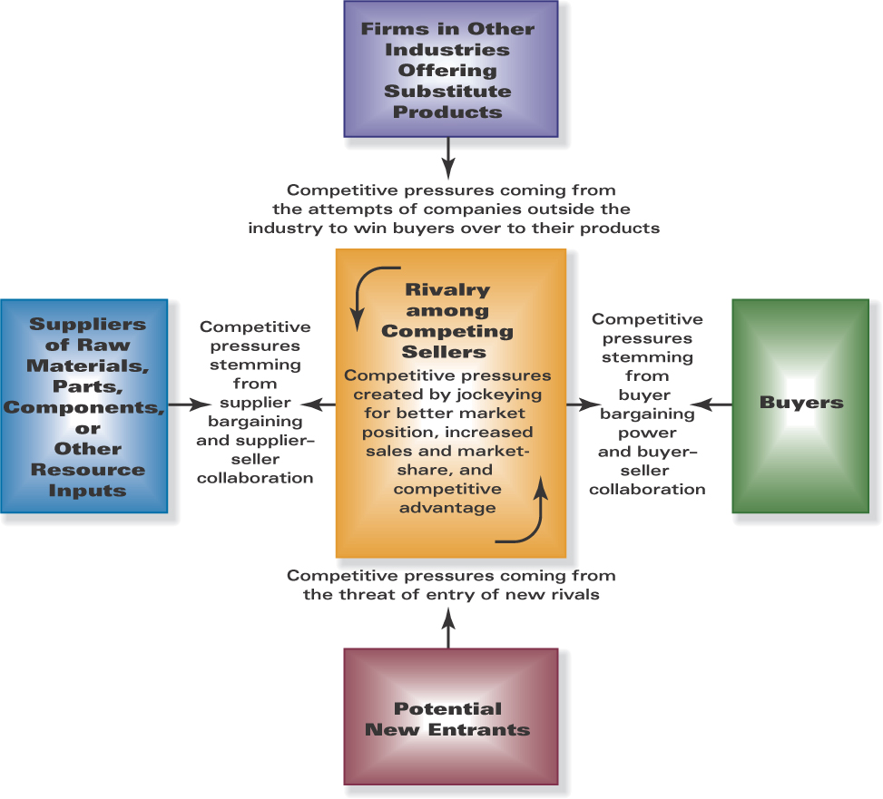

**Porter’s 5-Forces Model**

**Source: Thompson, Strickland & Gamble (2008), *Crafting and Executing Strategy***

### [Threat of New Entry](http://ehis.ebscohost.com/ehost/detail?hid=101&sid=0790ffe9-c060-4e65-9dbd-6f54526e754f%40sessionmgr110&vid=13&bdata=JnNpdGU9ZWhvc3QtbGl2ZQ%3d%3d" \l "toc" \o "Threat of New Entry )

New entrants into a market can really shake up an industry. A firm can lose market share, enter a costly battle to defend territory or lose leverage with customers and suppliers. When assessing the attractiveness of an industry with respect to new entrants, we look to mitigating factors called barriers to entry. These characteristics can help protect an industry from new entrants. Beckham (2006) outlined the major barriers to entry include:

1. **Economies of scale** — Economic efficiencies are vital to successful competition in many industries. In many cases, the higher the production volume, the lower the unit cost of production. This increased efficiency provides an advantage to firms that can produce large volumes. If economies of scale come into play in the industry, then a new entrant would either have to match the scale of the large producers or accept a cost disadvantage.
2. **Brand Identity** — Recognition in the marketplace can be hard for a new entrant to overcome. Brand loyalty takes time and money to build. A new entrant may need to spend heavily on advertising and in other areas such as customer service to displace the entrenched players.
3. **Proprietary Product Differences** — Companies which have patents or other proprietary knowledge can hamper a new entrant's success in the marketplace.
4. **Capital Requirements** — The requirement to invest significant financial resources to enter an industry can also inhibit new entrants. Whether it is manufacturing equipment, R&D or advertising expenditures, any large capital outlay will make a new firm think twice about market entry. An example would be the insurance or banking industry which requires a lot of capital as a bond payable to the Central Bank of Kenya.
5. **Absolute Cost Advantages** — Independent of the size of a company, there are some advantages that come with a track record in the industry. These advantages can arise from the effects of the experience curve, access to a superior supplier, favorable location, etc. New entrants may not be able to match established firms when it comes to these advantages.
6. **Switching Costs** — In some cases, consumers will incur additional expenses for switching from a product or service. Monetary penalties, such as an exit fee for breaking a contractual obligation, are employed in many industries. There can also be psychological switching costs that must be overcome to get consumers to change from the status quo.
7. **Government Policy** — The government can curb competition in an industry through policies and regulations. The government may have a limited number of licenses that can be given out to set up operations in a certain industry. Environmental regulations and granting of monopolies can also prevent a new firm from entering the market.
8. **Access to Distribution** — In many industries, there is a finite number of products that can be offered to consumers. Wholesalers and retailers do not have unlimited capacity. Therefore, there will always be a fight for shelf space. Existing players can lock up the distribution, making it hard for new entrants to get their products to the market. The more constrained the distribution outlet, the more limited the pool of players.
9. **Expected Retaliation** — The threat of new entrants can also be influenced by the expected reaction of existing players. If the existing players possess substantial resources to mount a fight or cut prices, new entrants are less likely.

Example of threat of new entrants is the recent entrant of YU mobile network provider in the Kenyan market who came with low calling costs. This forced the giants in the network to change their strategies and lower their prices. They had signed a contract with the government not to allow a third mobile provider thus recouping their investments which was blocking new entrants.

### [Bargaining Power of Suppliers](http://ehis.ebscohost.com/ehost/detail?hid=101&sid=0790ffe9-c060-4e65-9dbd-6f54526e754f%40sessionmgr110&vid=13&bdata=JnNpdGU9ZWhvc3QtbGl2ZQ%3d%3d" \l "toc" \o "Bargaining Power of Suppliers )

The relationship between a supplier and buyer is one of the most important aspects in business. Procurement of raw materials, labor and other supplies is vital to ongoing operations. Profits of a firm can be squeezed by suppliers exerting their power. Suppliers can raise prices, reduce quality, limit supply or even sign exclusive contracts with competitors. Beckham (2006) outlined that powerful supplier groups possess one or several of the following characteristics.

1. **Supplier Concentration** — If the industry is dominated by a few suppliers, this provides little choice for the buyer.
2. **High Switching Costs** — As discussed in the previous section, switching costs can prevent buyers from taking advantage of alternatives. In the case of a supplier-buyer arrangement, there may also be product specifications that tie a buyer to a particular supplier or the buyer could have invested in expensive equipment to process a particular supplier's raw materials. If the buyer will incur switching costs, then the supplier has more strength.
3. **Unique Product** — When there are few viable substitutes for the materials a firm is trying to procure, the supplier gains more power in the relationship. For example, the buyer could require a special component that has proprietary technology.
4. **Viable Forward Integration Threat** — When a supplier has the ability to enter the business themselves, it will prevent the buyer from getting too greedy.
5. **Serves Multiple Industries** — If a supplier's product can be used for many purposes in several different industries, then the supplier can be picky about whom they do business with.
6. **Marginal Customer** — A buyer may be an insignificant customer to the supplier because they do not purchase enough volume. In that case, the buyer may be the first to experience price increase, material shortages or lower quality products.

Example is the Kengen as the supplier to Kenya Power who has a lion share on the table as there are fewer or no other producers. Unga Ltd starting the animal feeds company stopped being suppliers of the same to other producers of the product. The re-insurers have leverage over the premium rates charged by the insurers as they must be based on the treaty arrangements between them.

### [Bargaining Power of Customers](http://ehis.ebscohost.com/ehost/detail?hid=101&sid=0790ffe9-c060-4e65-9dbd-6f54526e754f%40sessionmgr110&vid=13&bdata=JnNpdGU9ZWhvc3QtbGl2ZQ%3d%3d" \l "toc" \o "Bargaining Power of Customers )

Customers can also negatively impact an industry's profitability. Customers can push price down, require higher service and force competitors into costly battles for their patronage. Beckham (2006) summarized that powerful customer groups possess one or several of the following characteristics:-

1. **Concentrated or Large-Volume Buyer** — These big customers generally can make or break a company. These buyers are courted by many competitors in the industry and can usually capture concessions because of their power over the firm.
2. **Standardized Product** — These are undifferentiated products with ample alternatives. Because there is little brand identity and no switching costs, these are the most vulnerable to manipulation by customers.
3. **High Price to Total Purchase Ratio** — If what the buyer is purchasing constitutes a significant portion of total costs or total budget, the buyer is more likely to scrutinize the product and its price.
4. **Low Buyer Profits** — If a firm earns low profits, it is much more price sensitive than a firm that has a lot of cushion.
5. **Viable Backward Integration Threat** — If the buyer has the ability to acquire a similar company or build the product themselves, then they will have significant power over the firm.

Examples are the Mumias Sugar, the Kenya Cereal and Produce Board, KCC and other corporations who buy farmers products in bulk. Being the major buyers, their price fixing rarely considers the farmers who are considered their suppliers.

### [Threat of Substitutes](http://ehis.ebscohost.com/ehost/detail?hid=101&sid=0790ffe9-c060-4e65-9dbd-6f54526e754f%40sessionmgr110&vid=13&bdata=JnNpdGU9ZWhvc3QtbGl2ZQ%3d%3d" \l "toc" \o "Threat of Substitutes )

Substitutes can come in many forms. Threats can come from within the industry in the form of technology advances. They can also come from outside of the industry with a product that has a similar application. For example, plastic pallets could be a significant threat to a cardboard box manufacturer. The theory of supply and demand can be applied to this threat. The more viable substitutes there are in the market, the less demand and therefore the lower the price may be. If there are no switching costs and no brand loyalty, the threat of substitutes is considerable.

Example is Coca cola vs the mineral water companies. Due to water becoming the major substitute, Coca cola had to diversify to water selling business.

### [Rivalry Among Existing Competitors](http://ehis.ebscohost.com/ehost/detail?hid=101&sid=0790ffe9-c060-4e65-9dbd-6f54526e754f%40sessionmgr110&vid=13&bdata=JnNpdGU9ZWhvc3QtbGl2ZQ%3d%3d" \l "toc" \o "Rivalry Among Existing Competitors )

Competition between direct competitors in the marketplace will always be present. Firms can wage intense battles to try to steal market share from one another. Common tactics include price wars, new/improved product introduction, and escalation of advertising campaigns. Intense rivalry is characterized by one or several of the following factors:

1. **Slow Industry Growth** — An industry that is not expanding at fast enough rate to accommodate all players' growth ambitions, can set the stage for fierce competition. This is particularly true of mature industries where profits are on the decline. This scenario generally results in a shakeout of competitors with only a few surviving.
2. **High Exit Barriers**- Significant investment in customized equipment or assets may make it hard for a firm to exit a business. This may cause a company to continue to compete even after returns have been marginalized. Direct competition with these firms should be avoided because they will have incentive to cut costs to the point of razor thin margins or negative returns.
3. **Significant Fixed Costs** — This concept relates back to our discussion of economies of scale. When high volume production is necessary in order to maintain lower per units costs, there is a significant incentive to capture more market share. Market share battles usually involve price slashing and are quite damaging to profits.
4. **High Concentration and Balance** — When there are numerous competitors of relatively the same size, competition can be exaggerated. Competition in this kind of fragmented industry is intensified because they are all on relatively equal footing, competing for the same supplies and customers.
5. **Product Lacks Differentiation or Switching Costs** — Customers in this case can be very fickle and easily substitute one firm's product for another. The temptation to undercut competitors on price can lead to an unattractive proposition for all in the industry.
6. **High Diversity of Competitors** — When rivals differ in their strategies, philosophies and cultures, it is hard to predict what your competitors will do next. This instability can cause irrational, intense competition.

An example is the rivalry in the mobile industry where Safaricom and Airtel where price cutting and at time unethical advertisements are aired to woe customers. Price undercutting is also very common in the insurance industry.

**[Applications](http://ehis.ebscohost.com/ehost/detail?hid=101&sid=0790ffe9-c060-4e65-9dbd-6f54526e754f%40sessionmgr110&vid=13&bdata=JnNpdGU9ZWhvc3QtbGl2ZQ%3d%3d" \l "toc" \o "Applications )**

The five forces will impact every market differently. In some markets, the threat of new entrants is particularly heightened. In others, the bargaining power of suppliers can be disastrous for profits. The weaker these forces are, the greater the opportunity for high returns on investment. An industry that experiences intense threats on all fronts is not very attractive and most likely has diminished profit opportunities.

A competitive strategy can use these forces to find optimal positioning. Analysis of the five forces can indicate where the firm can best defend itself. It can also help anticipate change so that a firm is not caught off guard. Finally, the company should use what it knows about the industry to influence the forces in their favor. Understanding these forces can also highlight whether diversification or integration (vertical or horizontal) makes sense. We will further expand on the applications of the Five Forces when we discuss strategy formulation.

Porter's Five Forces have been criticized because some believe it does not consider the complete picture. Some academics have argued a sixth or even seventh force should be added. A possible sixth force could be stakeholders such as governments, employees, shareholders, creditors, etc. Another force that is not addressed in Porter's framework is the cooperative effect. The concept of complementors may explain the rationale behind the prevalence of strategic alliances.

**3. Technological Environment**

This determines the types of conversion process to be adopted. It includes inventions and techniques that affect the way of doing things i.e. the speed and quality of the production process and the distribution of products.

**4. Political and legal Environment**

Political stability has an impact on the form and structure of government administration. Political parties have ideologies and can also determine the level of bureaucracy. Legal groups thus play a restraining role to business activities.

**5. Social – cultural Environment**

This consists of attitude, beliefs, desires, expectations, education level and customs of the society at a given point in time. This can greatly influence business activity.

SWOT model

PESTEL Model